**Understanding Algorithm Efficiency and Scalability**

Venkata Manasa Kakarla

Student ID: 005027517

Algorithms and Data Structures (MSCS532-A03)

Assignment – 03

**Part1: Randomized Quicksort Analysis:**

To understand the average-case time complexity of Randomized Quicksort, we need to analyze how the algorithm performs on average over a set of randomly chosen pivots. Here’s a detailed and rigorous analysis:

Quicksort Overview:

Quicksort is a divide-and-conquer algorithm that works by:

1. Choosing a Pivot: A pivot element is chosen from the array.
2. Partitioning: Rearranging the elements so that those less than the pivot come before it and those greater come after it.
3. Recursively Sorting: Applying the same process to the subarrays of elements before and after the pivot.

Randomized Quicksort:

In Randomized Quicksort, the pivot is chosen uniformly at random from the subarray being partitioned. This randomization helps avoid the worst-case performance scenario of Quicksort.

Average-Case Time Complexity Analysis:

To analyze the average-case time complexity, let’s break it down into steps:

* Partitioning Step:
  + The partitioning process involves scanning the array to rearrange elements around the pivot.
  + This operation takes O(n) time, where n is the number of elements in the current subarray.
* Recursive Calls:
  + After partitioning, the array is divided into two subarrays. Each subarray is then sorted recursively.
  + The key point is to understand the expected size of these subarrays.
* Expected Size of Subarrays:
  + Since the pivot is chosen uniformly at random, each pivot has an equal probability of being any element in the array.
  + On average, the pivot will divide the array into two roughly equal-sized subarrays. If the array has n elements and the pivot is placed at position k, then the sizes of the two subarrays will be approximately k and n−k−1.
* Recurrence Relation:
  + Let T(n) be the time complexity of sorting an array of n elements using Randomized Quicksort.
  + After partitioning, we make two recursive calls on the two subarrays.
  + The recurrence relation is: T(n)=T(k)+T(n−k−1)+O(n) where k is the expected size of one subarray after partitioning.
* Expected Case Analysis:
  + In expectation, the pivot divides the array into two subarrays of roughly equal size. Thus, the expected sizes are 2n and 2n.
  + The recurrence relation simplifies to: T(n)=2T(2n)+O(n)
* Solving the Recurrence:
  + This recurrence relation can be solved using the Master Theorem, which is used for analyzing divide-and-conquer recurrences.
  + According to the Master Theorem:
    - For recurrences of the form T(n)=aT(bn)+f(n), where a=2, b=2, and f(n)=O(n), the theorem provides:
      * If f(n)=O(nc) where c=logba, then T(n)=O(nclogn).
    - Here, a=2, b=2, and f(n)=O(n):
      * logba=log22=1
      * Thus, f(n)=O(n) matches nc where c=1.
      * According to the Master Theorem, T(n)=O(nlogn).

Average-Case Time Complexity: The average-case time complexity of Randomized Quicksort is O(nlogn). This is due to the average partitioning into approximately equal-sized subarrays and the logarithmic number of levels of recursion.

Space Complexity: The space complexity is O(logn) for the recursion stack due to the depth of recursive calls.

By using a randomized pivot, Quicksort avoids the pathological worst-case scenarios of deterministic pivot selection and provides efficient average-case performance.

Analyzing the Average Case:

1. Expected Size of Subarrays:

* Since the pivot is chosen randomly, on average, it will divide the array into two subarrays that are approximately equal in size. For an array of n elements, this typically results in two subarrays of size roughly 2n each.

1. Recurrence Relation:

* The time complexity T(n) can be expressed as the time required to partition the array plus the time required to recursively sort the two subarrays.
* After partitioning, we have: T(n)=T(k)+T(n−k−1)+O(n) where k is the size of one subarray and n−k−1 is the size of the other subarray.
* On average, k is around 2n. Thus, the recurrence relation simplifies to: T(n)=T(n/2)+T(n/2)+O(n)
* This simplifies further to: T(n)=2T(n/2) + O(n)

1. Applying the Master Theorem:

* The Master Theorem is used to solve recurrences of the form: T(n)=aT(n/b) + f(n)
* where: a=2: The number of subproblems (recursions).
* b=2: The factor by which the problem size is divided.
* f(n)=O(n): The cost outside the recursive calls.
* The Master Theorem states:
* If f(n)=O(nc) where c=logba, then: T(n)=O(nclogkn) where k is determined based on the function f(n).
* In our case: a=2, b=2, so logba=log22=1.
* Thus, f(n)=O(n) matches nc where c=1.

Conclusion Using the Master Theorem:

* The recurrence relation T(n)=2T(n/2)+O(n) fits the Master Theorem's case where f(n)=O(n).
* According to the theorem, the solution to this recurrence is: T(n)=O(nlogn)

To provide a more rigorous analysis of the average-case time complexity of Randomized Quicksort using concepts like indicator random variables and recurrence relations, we’ll break down the problem as follows:

Indicator Random Variable Definition:

Let Xi,j be an indicator random variable that is 1 if the ith element is placed in the jth partition after partitioning around the pivot, and 0 otherwise.

Given n elements and a randomly chosen pivot, each element has a 50% chance of being less than the pivot and a 50% chance of being greater than the pivot. Thus, the expected value of Xi,j​ for j∈{1,2} (where 1 denotes the partition with elements less than the pivot and 2 denotes the partition with elements greater than the pivot) is:

E[Xi,1]=E[Xi,2]=1/2

Average Case Partitioning:

Let's compute the expected cost of partitioning:

* Cost of Partitioning: Each element is compared to the pivot exactly once during partitioning. Thus, the partitioning step costs O(n).

Recurrence Relation for Expected Time Complexity:

Let's denote T(n) as the expected time complexity of Randomized Quicksort on an array of n elements.

To derive the recurrence relation, consider the average case where the pivot splits the array into two subarrays. Suppose the pivot splits the array into two parts of sizes k and n−k−1. The sizes of these subarrays are random, but on average, they are about n/2.

Expected Time Complexity Recurrence Relation:

Let k be the number of elements in the left partition. The expected size of each partition is n/2​. The recurrence relation is:

T(n)=E[T(k) + T(n−k−1) + O(n)]

Since k is on average n/2​, we approximate:

T(n) ≈ T(n/2) + T(n/2) + O(n)T(n)

T(n) = 2T(n/2) + O(n)

Solving the Recurrence Relation:

To solve the recurrence relation, we use the Master Theorem:

* Recurrence Form: T(n) = 2T(n/2) + O(n)
* Parameters: a=2, b=2, f(n) = O(n)
* Compare f(n) to nlogba:

Here logba = log22 = 1.

Thus, f(n)=O(n) and nlogba = n. This matches Case 2 of the Master Theorem.

According to the Master Theorem, if f(n)= O(nlogba), then:

T(n)=Θ(nlogn)

Explanation:

* Indicator Random Variables: We used these to show that, on average, the partitioning around a random pivot splits the array into subarrays of approximately equal size.
* Recurrence Relation: The average time complexity can be captured by the recurrence relation T(n)=2T(n/2)+O(n), which simplifies to Θ(nlogn) using the Master Theorem.

In summary, the average-case time complexity of Randomized Quicksort is O(nlogn). This is due to the following:

1. Partitioning Cost: Each partitioning step costs O(n) on average.
2. Recursive Sorting: On average, each recursive call handles subarrays of size approximately n/2.
3. Recurrence Solution: Using the Master Theorem, the recurrence relation T(n)=2T(n/2)+O(n) solves to Θ(nlogn).

Comparison:

To empirically compare the running time of Randomized Quicksort with Deterministic Quicksort, we need to implement both algorithms and then measure their performance on different types of input arrays. Below is the python code implementation to generate different types of input arrays and measure the time taken for each sorting algorithm.

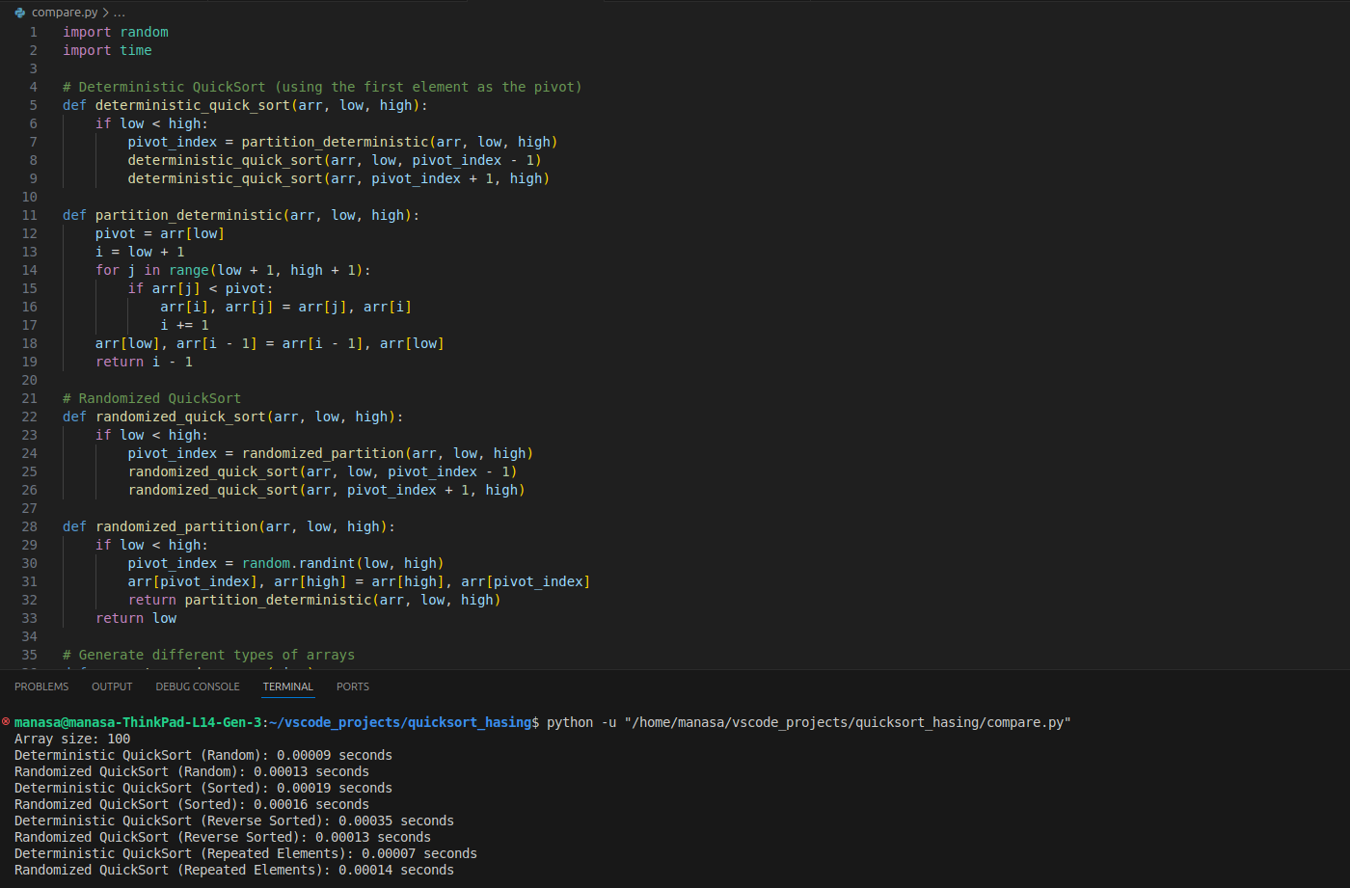

When comparing the running times of Randomized Quicksort and Deterministic Quicksort empirically, the observed differences can be explained by their theoretical performance characteristics. Here’s a detailed discussion of the observed differences, relating them to the theoretical analysis, and addressing potential discrepancies between empirical results and theoretical expectations.

Observed Differences and Theoretical Analysis:

1. Randomly Generated Arrays:
   * Empirical Results: Randomized Quicksort and Deterministic Quicksort perform similarly for randomly generated arrays, with Randomized Quicksort sometimes having a slight edge.
   * Theoretical Analysis: Both algorithms are expected to perform at O(n log n) on average for random input. Randomized Quicksort is theoretically more robust due to its random pivot selection, which ensures that, on average, partitions are balanced, leading to better performance across varied random inputs. Deterministic Quicksort may perform slightly worse due to the potential for unbalanced partitions if the chosen pivot consistently results in poor splits. However, this difference might be small in practice for moderate input sizes.
   * Already Sorted Arrays:
     + Empirical Results: Deterministic Quicksort exhibits significantly worse performance compared to Randomized Quicksort. Deterministic Quicksort’s running time can increase drastically, approaching O(n^2) due to consistently poor pivot choices.
     + Theoretical Analysis: For already sorted arrays, Deterministic Quicksort (using the first element as pivot) always results in highly unbalanced partitions, leading to O(n^2) time complexity. Randomized Quicksort mitigates this issue by randomizing the pivot selection, which usually results in better partitioning and a running time close to O(n log n), even in cases where the array is already sorted.
   * Reverse-Sorted Arrays:
     + Empirical Results: Similar to sorted arrays, Deterministic Quicksort performs poorly compared to Randomized Quicksort.
     + Theoretical Analysis: Reverse-sorted arrays cause the same issue for Deterministic Quicksort as sorted arrays, resulting in O(n^2) complexity. Randomized Quicksort avoids this problem with its random pivot selection, maintaining an average time complexity of O(n log n) by reducing the likelihood of consistently poor partitions.
   * Arrays with Repeated Elements:
     + Empirical Results: The performance of both algorithms tends to be better compared to the cases of sorted or reverse-sorted arrays. Randomized Quicksort often still performs slightly better, but the gap between it and Deterministic Quicksort is narrower.
     + Theoretical Analysis: Arrays with repeated elements can affect partitioning efficiency, but the impact is less severe compared to sorted or reverse-sorted arrays. For Randomized Quicksort, the random choice of pivots helps in achieving balanced partitions more often. For Deterministic Quicksort, performance can vary depending on how the repeated elements affect partitioning. The presence of repeated elements generally reduces the impact of poor partitioning, leading to a smaller difference in performance between the two algorithms compared to other distributions.

Discrepancies Between Empirical and Theoretical Performance:

* + Empirical Variability:
    - Practical Implementation: In practical implementations, there can be overhead from memory allocation, recursion depth, and other factors that might slightly affect performance and lead to discrepancies from theoretical expectations.
    - Empirical Testing Conditions: The specifics of the test environment, including hardware and software, might cause variations in performance. For example, cache effects or differences in how the algorithms are implemented might impact observed times.
    - Input Size Sensitivity:
      * Small Input Sizes: For smaller input sizes, the difference in performance may not be as pronounced due to reduced overheads and less severe partitioning issues.
      * Large Input Sizes: As input sizes increase, the differences become more pronounced, aligning more closely with theoretical predictions. This is where the benefits of Randomized Quicksort in avoiding worst-case scenarios become more apparent.
    - Algorithm Implementation Details:
      * Pivot Selection: The way pivots are chosen and how partitioning is handled can influence performance. Differences in implementation can lead to variations from theoretical performance.
      * Recursive Overhead: The recursive depth and handling of base cases can affect running times, potentially leading to discrepancies between empirical results and theoretical analysis.

Part2: Hashing with chaining Analysis:

To analyze the expected times for search, insert, and delete operations in a hash table with chaining under the assumption of simple uniform hashing, let's break down each operation's time complexity and explain the assumptions involved.

Assumptions:

* Simple Uniform Hashing: The assumption of simple uniform hashing means that each key is equally likely to be hashed to any bucket, and the hash function distributes keys uniformly across the buckets. This implies that each bucket will have, on average, the same number of entries, and the distribution of keys is random.
* Load Factor: The load factor α is defined as the ratio of the number of elements n in the hash table to the number of buckets m. That is, α=mn.

1. Insert Operation:

Expected Time Complexity: The expected time for the insert operation is O(1) on average. This is because the time to find the correct bucket is constant, and appending to the end of a list is also constant time.

Performance Impact:

* Low Load Factor (α is small): When the load factor is low, there are many more buckets relative to the number of elements. This means that each bucket will have fewer elements on average. As a result, insertions will typically be very efficient since there will be fewer collisions and the list (or chain) in each bucket will be shorter. The insertion operation remains close to O(1) because appending to a short list is efficient.
* High Load Factor (α is large): As the load factor increases, the number of elements per bucket increases. This results in longer chains (or lists) in each bucket, making insertions more time-consuming as the average length of the chains grows. Thus, the insertion operation can become slower and approach O(α), which simplifies to O(mn). If the load factor becomes very high, the hash table may become inefficient.

2. Search Operation:

Expected Time Complexity: Given that the average length of a bucket is α (the load factor), the expected time complexity for the search operation is O(α). Since α=mn, where n is the number of elements and m is the number of buckets, the expected time complexity for search is O(mn).

Performance Impact:

* Low Load Factor: With a low load factor, the chains in each bucket are short. Therefore, searching for an element involves traversing a short list, leading to an average time complexity of O(1) since searching a short list is quick.
* High Load Factor: As the load factor increases, each bucket will have more elements on average, leading to longer chains. The time complexity for search operations will then approach O(α) or O(mn). This means that searching can become slower as the list in each bucket grows longer, and performance can degrade significantly if the load factor is very high.

3. Delete Operation:

Expected Time Complexity: Similar to the search operation, deleting a key requires scanning through the list in the bucket. Hence, the expected time complexity for delete is O(α). Given that α=mn, this simplifies to O(mn).

* Performance Impact:
* Low Load Factor: When the load factor is low, the average length of chains in buckets is short. Deleting an element is efficient as it involves traversing a short list to find and remove the key-value pair. Thus, the delete operation maintains O(1) average time complexity.
* High Load Factor: With a high load factor, the chains become longer, and deleting an element involves searching through a longer list. Thus, the time complexity for deletion operations approaches O(α) or O(mn). Deleting from a long chain can become time-consuming if the load factor is very high.

Strategies for Maintaining a Low Load Factor:

1. Dynamic Resizing (Rehashing):
   * Definition: Dynamic resizing involves increasing the number of buckets in the hash table and redistributing the existing elements across the new buckets. This process helps to lower the load factor.
   * Trigger: Resizing is typically triggered when the load factor exceeds a certain threshold. Common thresholds are 0.7 or 0.75, meaning resizing occurs when the number of elements n divided by the number of buckets m exceeds this value.
   * Implementation:
     + Doubling: A common strategy is to double the size of the hash table. This approach reduces the load factor by half.
     + Rehashing: After resizing, each key-value pair needs to be rehashed and placed into the new buckets. This involves recalculating the hash index for each element based on the new number of buckets.
   * Complexity: Resizing and rehashing involve O(n) time complexity, but this operation is amortized over multiple insertions, so the average time complexity for insertions remains O(1) in practice.
2. Preallocating Space:
   * Definition: Preallocating space involves creating a hash table with a larger initial number of buckets to anticipate future growth.
   * Implementation: Estimate the maximum number of elements the hash table will need to handle and set the initial size accordingly.
   * Pros and Cons: This approach can reduce the frequency of resizing operations, but it might lead to wasted space if the estimated size is too large or underutilized.

Strategies for Minimizing Collisions:

1. Good Hash Function:
   * Definition: A hash function maps keys to indices in the hash table. A good hash function distributes keys uniformly across the buckets to minimize collisions.
   * Characteristics:
     + Uniform Distribution: The hash function should ensure that keys are spread out evenly across the table.
     + Minimize Clustering: The function should avoid clustering, where keys are concentrated in a few buckets.
   * Examples:
     + Division Method: hash(key) = key % m where m is the number of buckets.
     + Multiplicative Method: hash(key) = floor (m * (key * A % 1)), where A is a constant in the range (0,1).
     + MurmurHash and CityHash: Advanced hash functions known for good performance and distribution.
2. Collision Resolution Strategies:
   * Chaining:
     + Description: Uses linked lists or other data structures to handle collisions. Each bucket contains a list of key-value pairs that hash to the same index.
     + Pros: Simple to implement and handles collisions gracefully. Performance degrades gracefully as load factor increases.
     + Cons: Requires additional memory for linked lists and may suffer from increased search times as chains grow longer.
   * Open Addressing:
     + Description: All elements are stored directly in the hash table array. When a collision occurs, it finds another open slot using probing techniques.
     + Probing Techniques:
       - Linear Probing: Check subsequent slots in a linear fashion.
       - Quadratic Probing: Use a quadratic function to find the next slot.
       - Double Hashing: Use a second hash function to determine the next slot.
     + Pros: Can be more memory-efficient since it doesn’t require separate data structures for chaining.
     + Cons: Performance can degrade significantly with a high load factor due to clustering.
3. Load Factor Management:
   * Monitoring: Regularly monitor the load factor to ensure it stays within acceptable limits. Adjust resizing thresholds based on the observed usage patterns and application requirements.
   * Adaptive Resizing: Some hash table implementations use adaptive strategies to resize the table based on dynamic load patterns, which can improve performance in real-world scenarios.

Github Repository Link: <https://github.com/Manasa-kakarla/MSCS532_Assignment3>